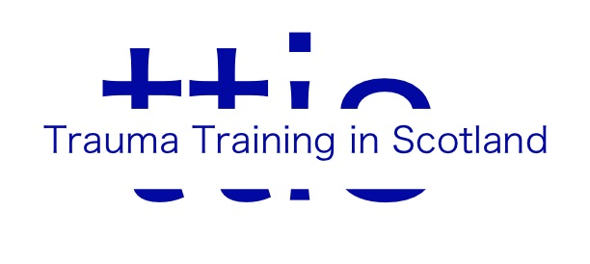
Booking Form

Name of Event:
Date(s):
Booking reference (see Further Information):
Your name:
Participant’s name (if different):
Email:
Contact Telephone:
Occupation:
Any particular needs? (please specify)

Amount paid:

Method of Payment (delete as appropriate): BACS*/Cheque**

*BACS payments can be made to CAF Bank, Sort Code: 83-91-46; Account number: 20401038. If paying by BACS, please return this form to traumatraininginscotland@gmail.com
**Booking forms with cheque payments should be sent to TTiS, c/o Park Therapy Practice, 15 Newton Terrace, Glasgow, G3 7PJ. Cheques should be made payable to Trauma Training in Scotland.

Cancellation Policy
More than three months’ notice of cancellation – full refund minus 10% admin charge
6 weeks to three months’ notice – 75% refund minus admin charge
2 to six weeks’ notice – 50% refund minus admin charge
Less than 2 weeks’ notice –no refund

